EU CSA Compliance for Log360
Strengthen data protection and meet EU CSA compliance with Log360.
Region: EU | Type: Data Privacy, Incident Management | Category: Compliance | Pricing: Free

Overview
The EU CSA compliance extension in Log360 helps organizations meet the EU Cybersecurity Act (Regulation (EU) 2019/881), an EU regulation strengthening ENISA's mandate and establishing a cybersecurity certification framework for ICT products and services by providing centralized log management, real-time threat detection, and identity access monitoring. The platform supports EU CSA requirements for governance, incident reporting, identity management, access control, network security, data protection, privileged access, and vulnerability assessment.
For Governance and Security Policy Management, Log360 tracks AD user auditing, GPO and policy changes, group and OU management, and computer auditing to evidence governance compliance. To address Incident Reporting and Threat Detection, the platform delivers real-time threat detection via FireEye, Trend Micro, Windows/Unix threat reports, and network attack monitoring. The extension also supports Identity and Access Management by providing capabilities that captures Windows and Unix logon/failed logon events, AD and Entra ID logon activity, and MFA authentication reports.

Key Features
- Security Assurance and Audit Logging: Log360 aggregates Windows system events, EventLog data, Oracle and SQL Server audit logs, and Exchange mailbox records into immutable audit trails.
- Network Security and Perimeter Controls: Log360 audits network device logon attempts, account management, policy changes, security events, and firewall configurations.
- Data and Endpoint Protection: Log360 tracks file changes, Windows registry modifications, USB storage auditing, Unix removable disk activity, and firewall auditing.
- Privileged Access Management: Log360 tracks Unix SUDO commands, user account management, group changes, and policy modifications to audit privileged access across platforms.

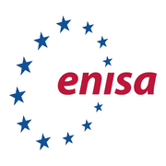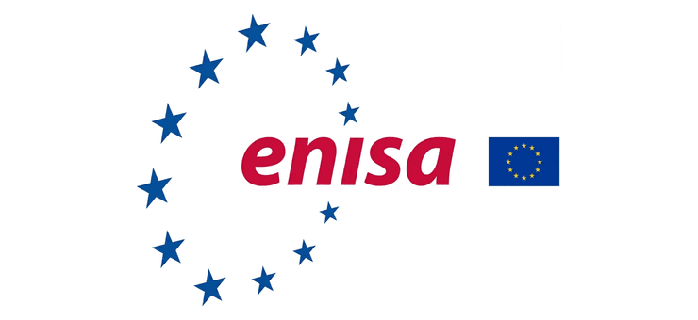
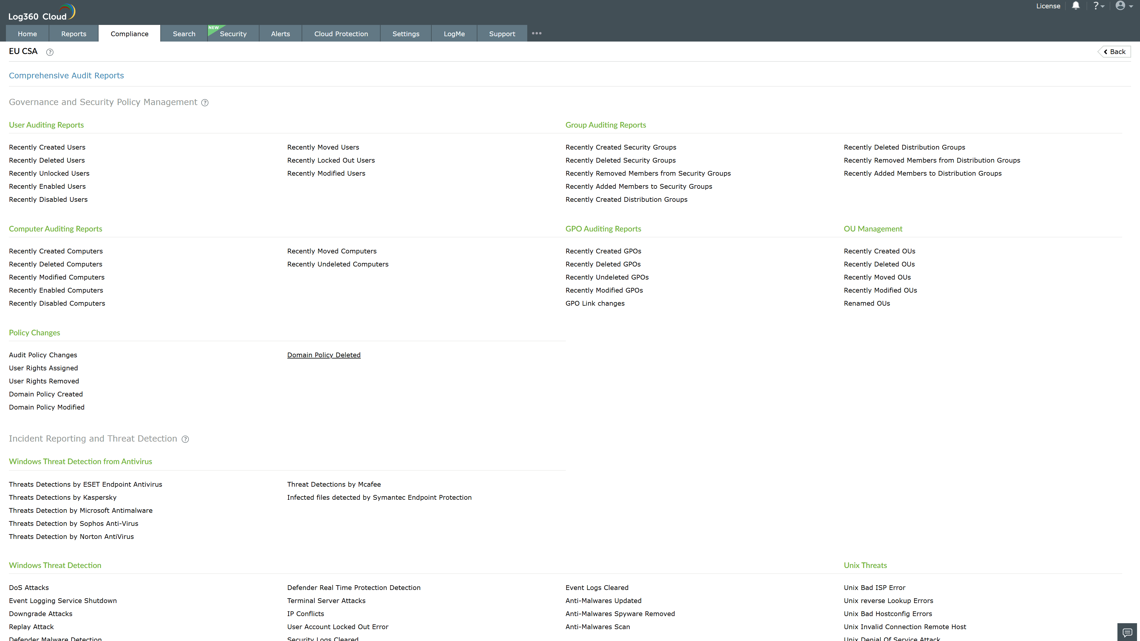
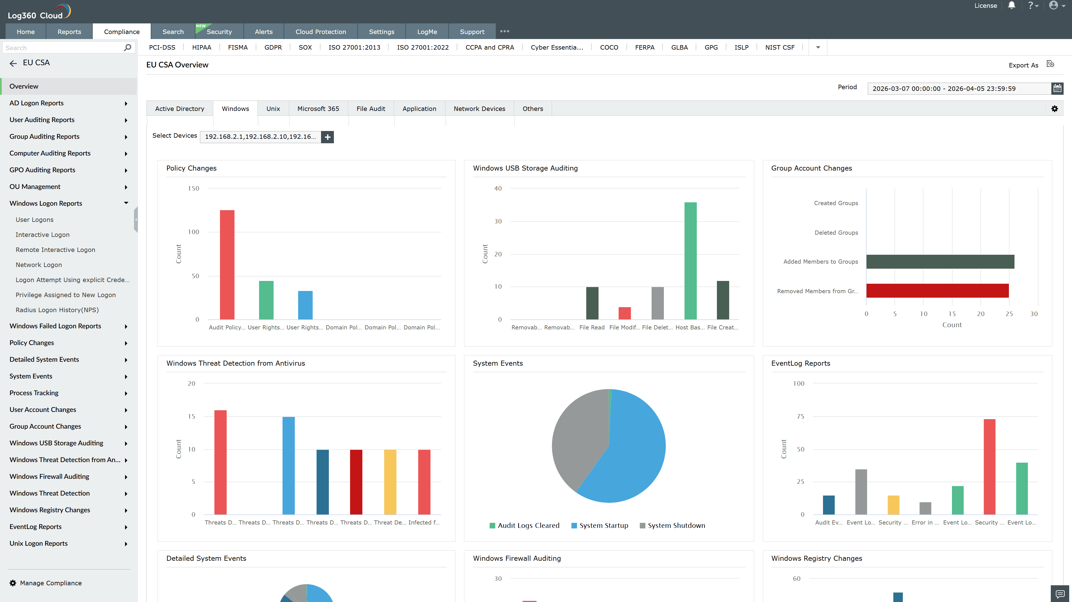
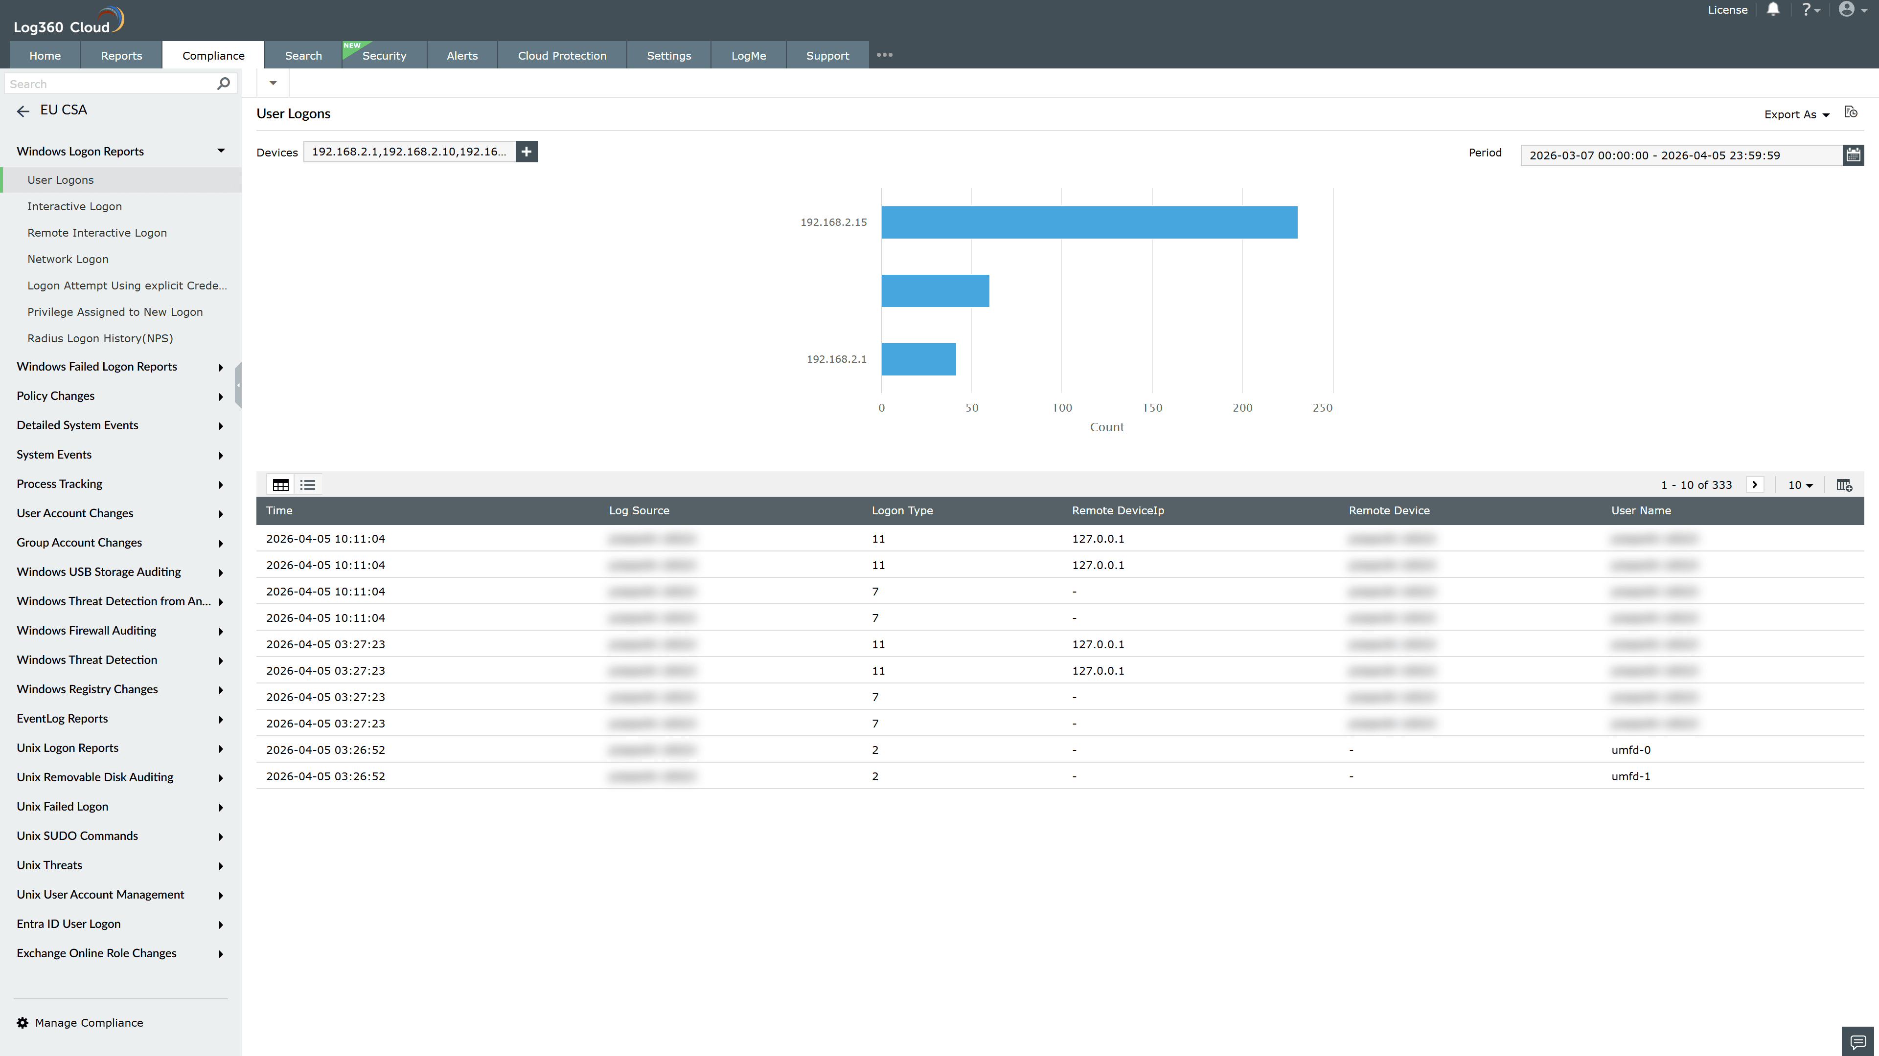
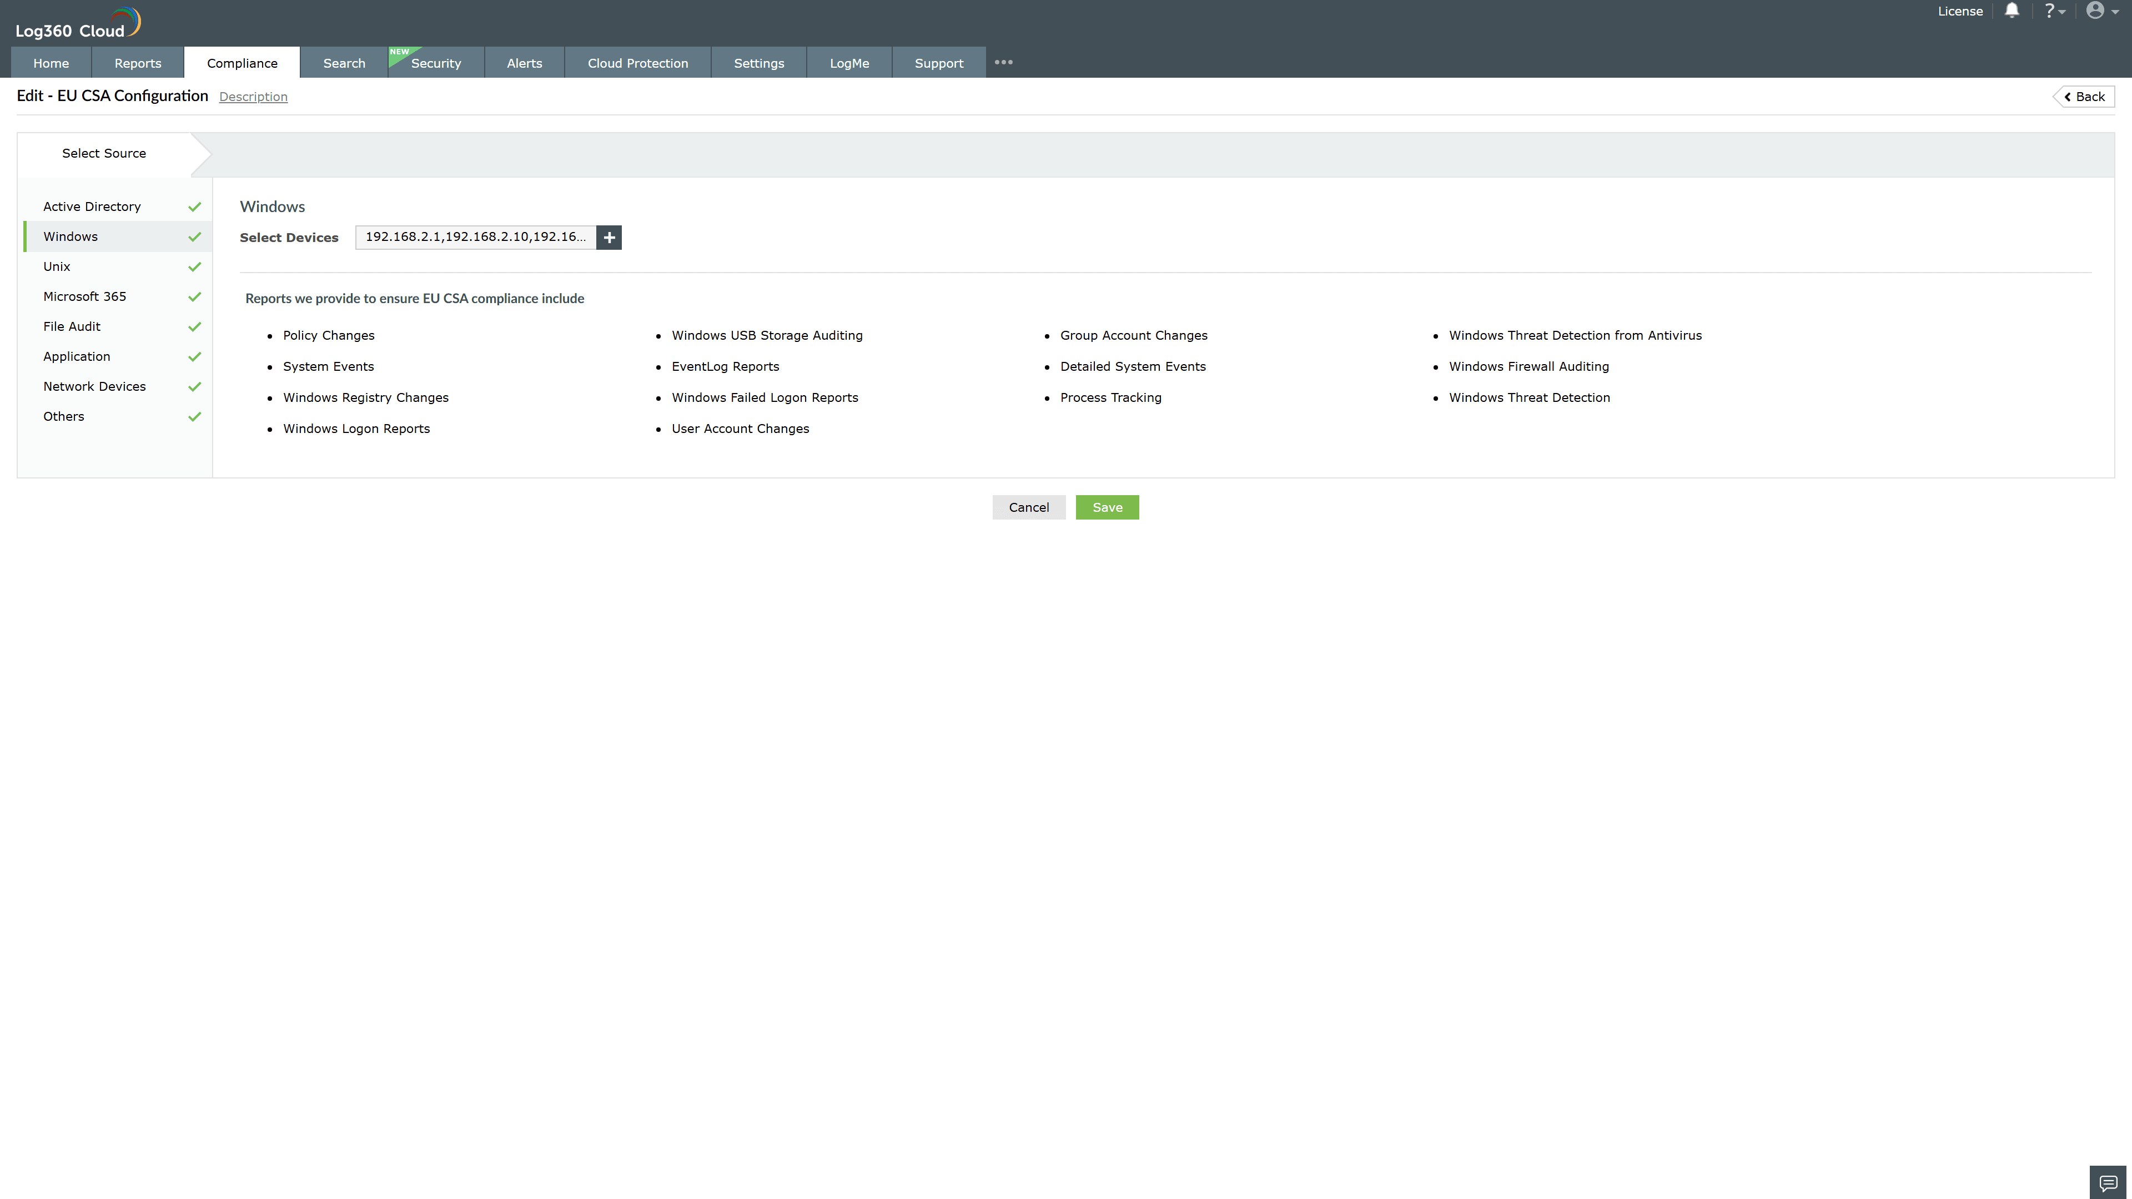
Valid Submission : Yes
Supported Editions : Free, Basic, Standard, Professional, MSSP
Help Document : https://www.manageengine.com/log-management/help/integrations/compliance-extensions.html
Help Video : Not provided
Tags : Log360, Compliance, Privacy monitoring, Data privacy, Regulatory compliance
Supported DCs : US, IN, JP, CA, AU, UK and EU
Privacy Policy:
Terms of Service:
Release Notes:
Predefined reports for the EU CSA.

